|  |  |
| --- | --- |
| Course Name | ITD 2313 – Script Programming |
| Instructor | Mark L. Pranger |
| Student Name | Thomas Webb |
| Due date | 6/17/2025 |
| Grade | Put grade earned here |
| Grading Comments | Put instructor comments here |

Steps 1

Step 2

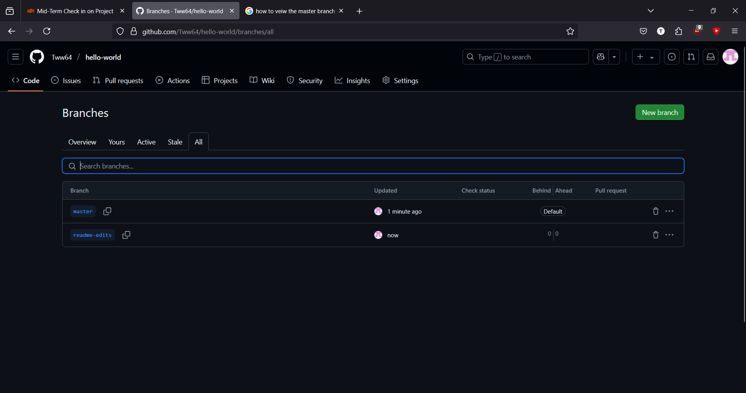

Step 3

Step 5

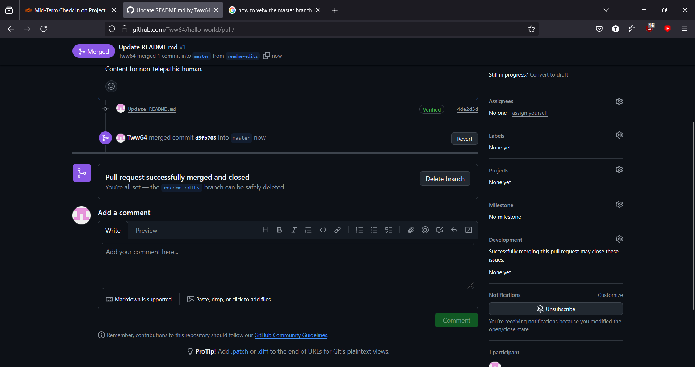

Item 2

STe